CONVENTION OF STATES TIPS FOR PUBLIC EVENTS

If you’re looking for a way to spread the word about Convention of States and gain multiple petition signatures from freedom-loving Americans, look no further than the many public events here in Colorado. Consider arranging a booth at trade shows, county fairs, local festivals, farmer’s markets, political events, etc. Here are some helpful tips and suggestions from COSA volunteers who have pitched in during public events in Colorado.

BEFORE THE EVENT:

- Line up your COS volunteers in advance so you know who is attending when. You may want to print off a list to keep at the booth, so volunteers know who will relieve them, and when.
- When contacting the show sponsor, request a table with the most traffic and visibility.
- Communicate with your volunteers to ensure they’re set up for success. If you expect them to bring anything with them, be clear on this and call or text a reminder the day before their shift.

WHAT TO BRING:

- If you’re in charge of setting up the booth, you’ll need to bring:
  - A tablecloth (unless the event sponsor specifically says they are providing these; some do, some don’t, so if it’s unclear, assume one is not provided for you.)
  - COS literature, posters, and signage, plus any necessary stands or easels for display. Here is an example of a well-appointed COS booth:
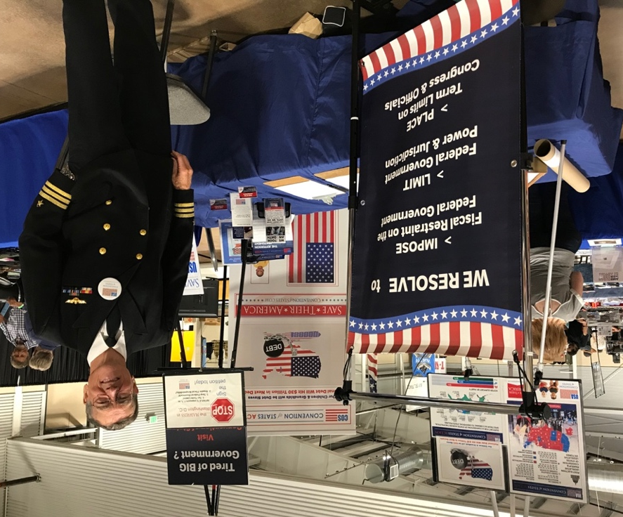
  - Clipboards and pens
  - Printed copies of the petition
  - COS information flyers and acrylic display stands
  - If you bring a laptop with the intention of folks signing digitally, be sure to bring a charging brick and/or extra battery and a super long extension cord. Remember, there may or may not be wi-fi available at the venue.

- Everyone volunteering at the booth can bring:
  - A friendly smile, your passion for change, and your amazing COS knowledge
  - Water, snacks, and sustenance for your shift
  - COS attire, buttons, etc., or perhaps your military uniform if applicable

WHEN YOU ARRIVE AT THE EVENT:

- Plan to arrive early and set up your table or booth quickly, as there is typically a half-hour lull between vendor setup and open doors to the public. This is an ideal time to chat up other vendors for education, interest, and petition signing.
- It can be helpful to set a personal signature goal for your volunteer shift. This is a specific number to keep in your mind, and it will help you stay motivated when the crowd thins. Depending on the amount of foot traffic at your show and how many people are manning the COS booth, 20-30 is a great first-time goal. If you find you hit that number quickly, use this as motivation to regroup and set an even bigger goal for the day.

HELPFUL HINTS DURING THE EVENT:

- Here are some conversation openers:
  - “Have you heard of Convention of States?”
  - “Do you support 1. Term limits 2. Fiscal Responsibility 3. Less Federal Power?
Great! Please sign our petition.”
  - “Do you think Colorado should protect your ___ rights?” Fill in the blank with whatever right(s) are most relevant to the event (second amendment, freedom of speech, religious rights, etc.), or substitute the word “rights” with “Constitutional freedom.”
  - “Do you think our government is too big or too small?”
  - “Are you aware that the Constitution gives us a way to stop government overreach?”

- Remember to ensure signers include their complete residential (street) address or voter registration address. Incomplete addresses or P.O. boxes make it nearly impossible to determine the signer’s voting district, which we require in order to send their signature to the correct state legislator.
- When talking to married couples, be sure to get both to sign the petition separately. The same is true for families attending with children over the age of 18.
- Maximize your time by chatting up other vendors at any time the crowd in attendance is low. Many small business owners are conservative, frustrated with government overreach, and happy to hear about ways to “fix” leadership in our country.
- Remember: the goal is gain petition signers. If you are talking to someone who is interested and you’ve asked them to sign but they seem hesitant, ask “what other questions or concerns can I answer for you?”
- If they want to think about it or don’t want to sign on the spot, offer them a copy of the petition to take with them to mail, and/or a flyer so they can sign online.
- Expect another lull in the 20-30 minutes before the show closes for the night. Some vendors are deciding whether to pack up early as the crowd dwindles to a trickle, and this can be another great time to collect vendor signatures.

GUN SHOW ETIQUETTE

- Please avoid interrupting another vendor during setup, sales pitch, or closing a sale. Remember, their primary reason for being at the show is to make sales, so be mindful not to infringe upon that objective.
- Don’t feel tied to the COS table when there’s a lull in the crowd. Get out and mingle, pass out flyers, or bring your petition around on a clipboard.
- Have fun! When you bring a smile and a passion for COS, you are likely to meet plenty of friendly people who want to see our Constitutional rights protected. Because COS seeks to limit government overreach, public events are often a natural fit.

