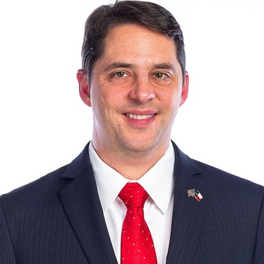
Shelby Williams is a previous State Director of Texas for the Convention of States, a current City Council member in Plano, and a conservative activist. He joined the Article V movement in late 2013 after reading Mark Levin’s book “The Liberty Amendments”. He has served as an alternate-delegate to the 2016 Republican Convention in Cleveland. He also served in the 2020 Legislative Priorities Committee for the Republican Party of Texas. Shelby has a long-standing commitment to the Rule of Law under the Constitution and representative government.

Shelby and his wife, Mariya, have been married for 21 years and are raising three beautiful daughters Valery, Olivia and Katherine. Shelby graduated with a Master in Business Administration (MBA) from the University of Texas at Austin and has enjoyed a successful career in business Technology.

