11/4/2023 Rev. 0
By Van W. Walter
For new COS members who still need to confirm their account.

- For a new account and an unconfirmed account.
Use the email you used to sign your petition.
Enter a password and retype.
- You will then be sent a confirmation email; follow the instructions received, and you are all set.
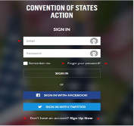
Forgot Password:
If you can’t find your confirmation email, use the Forgot Password option and click on the didn’t receive confirmation instructions email using the email you used when you signed your petition.
